Event Management System

In this project event publisher can create events and then view list of events and can add location address of each event and can update or delete event location. Event publisher added events can be view by normal public as event announcement.

SCREEN SHOTS

Create database by copy content from ‘db.txt’ file and paste in MYSQL

Then install tomcat and deploy code and then run from browser to get below screen

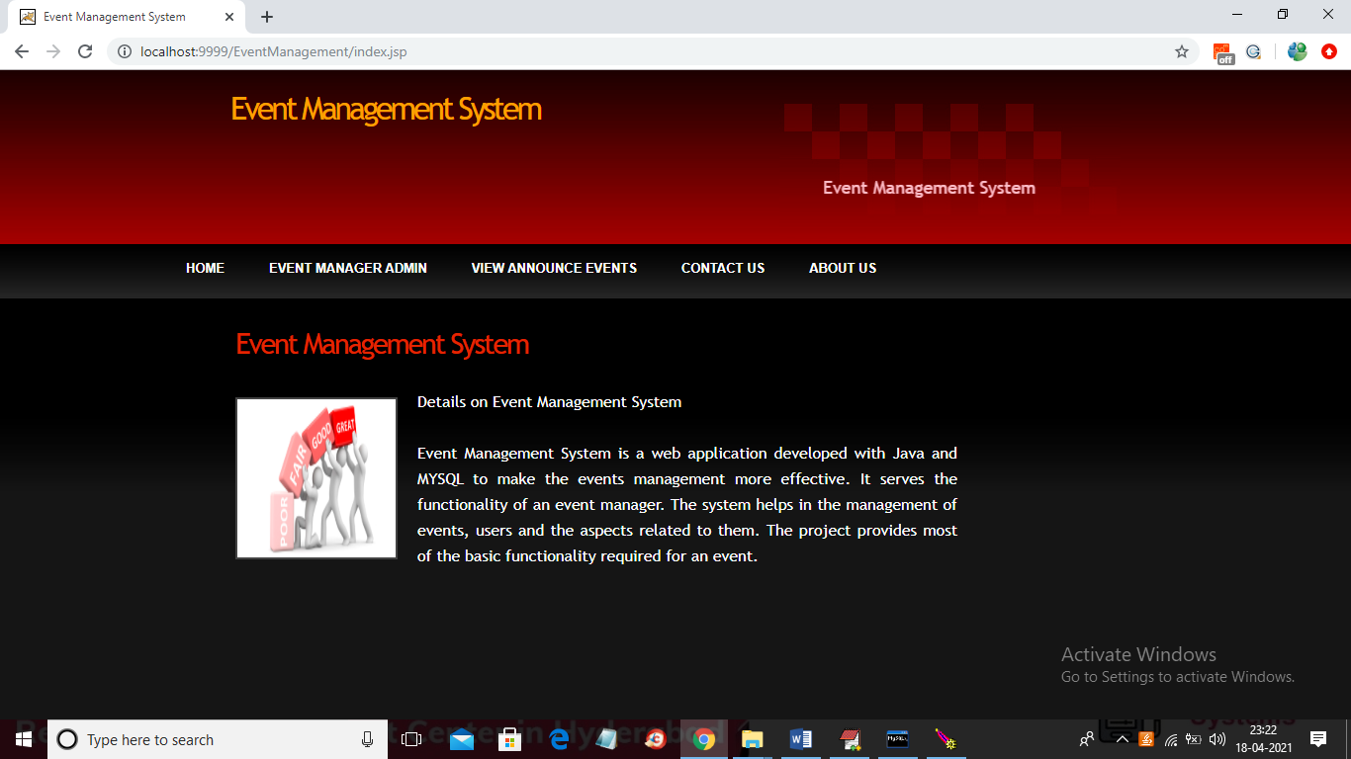

In above screen click on ‘Event Manager Admin’ link to get below login screen

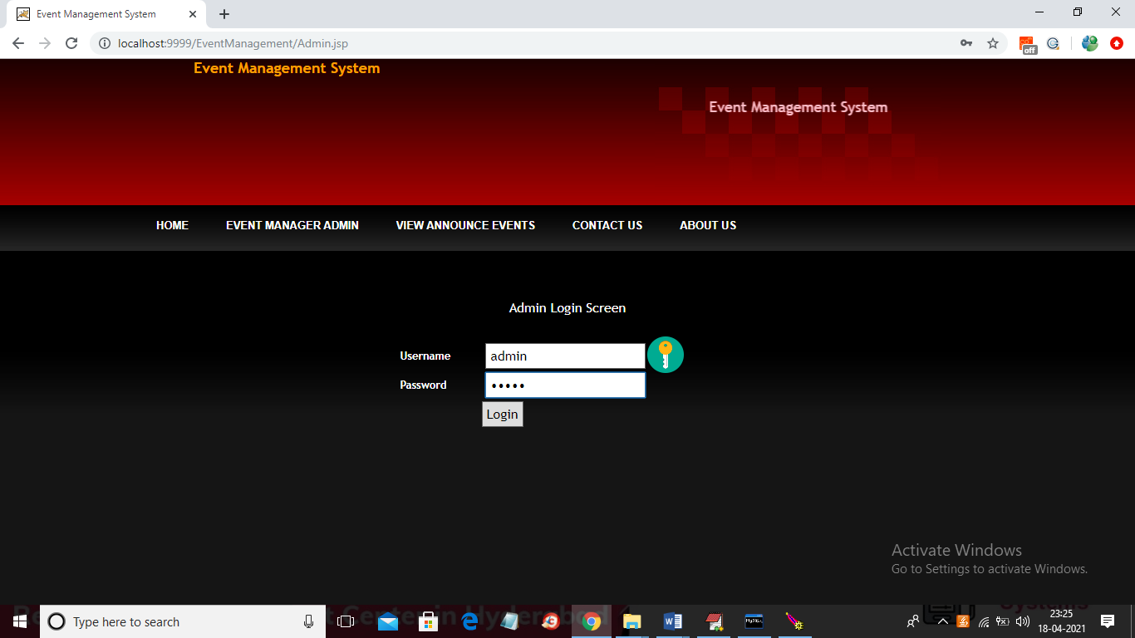

In above screen enter username and password as admin and then click on button to get below screen.

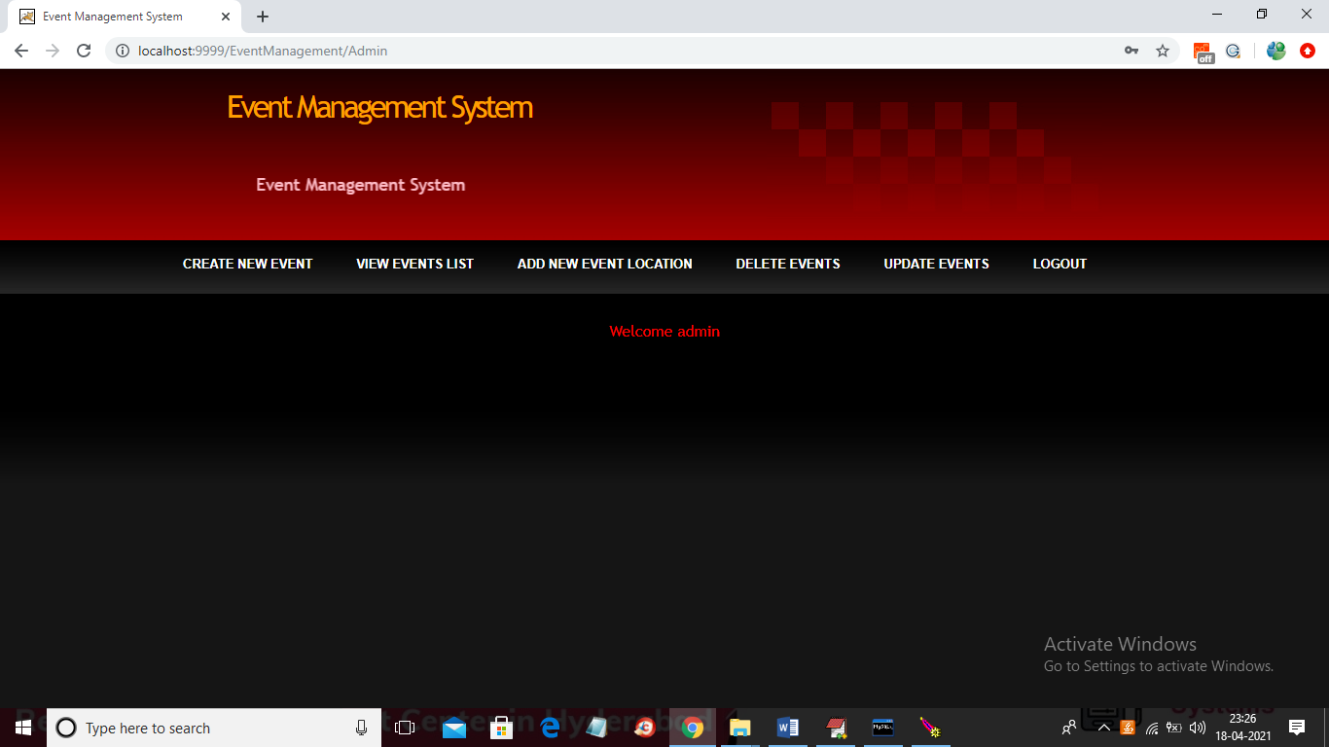

In above screen click on ‘Create New Event’ link to add new event details

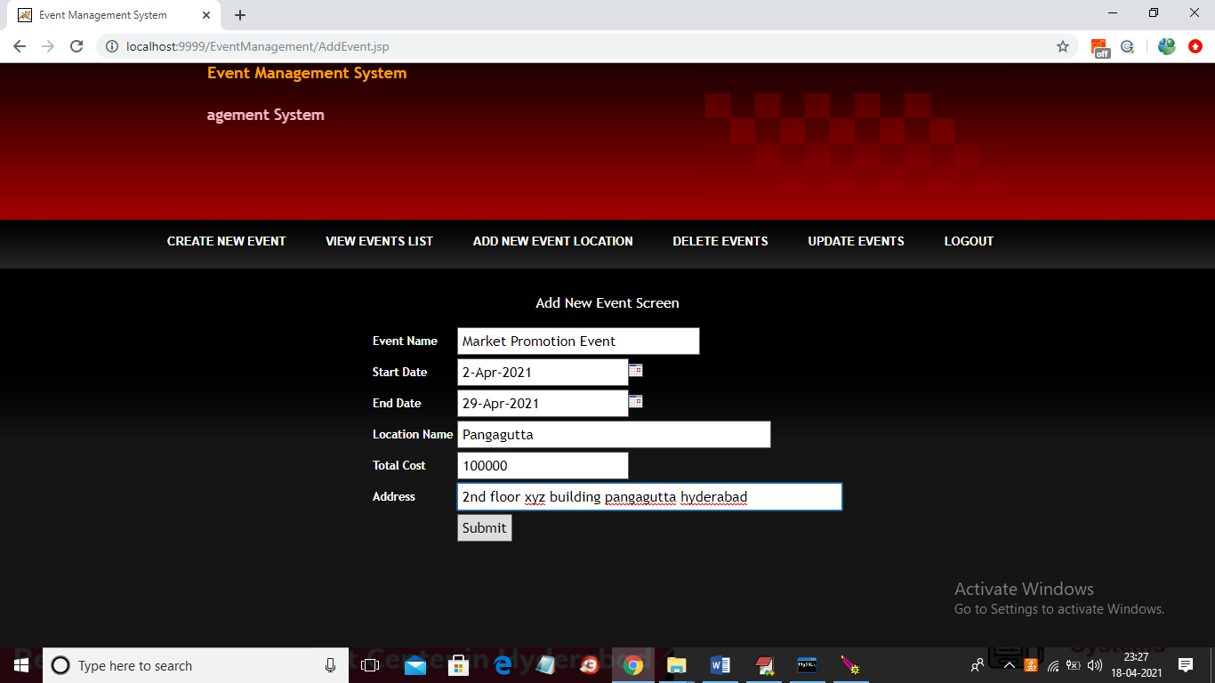

In above screen adding event details and then click on ‘Submit’ button to get below screen

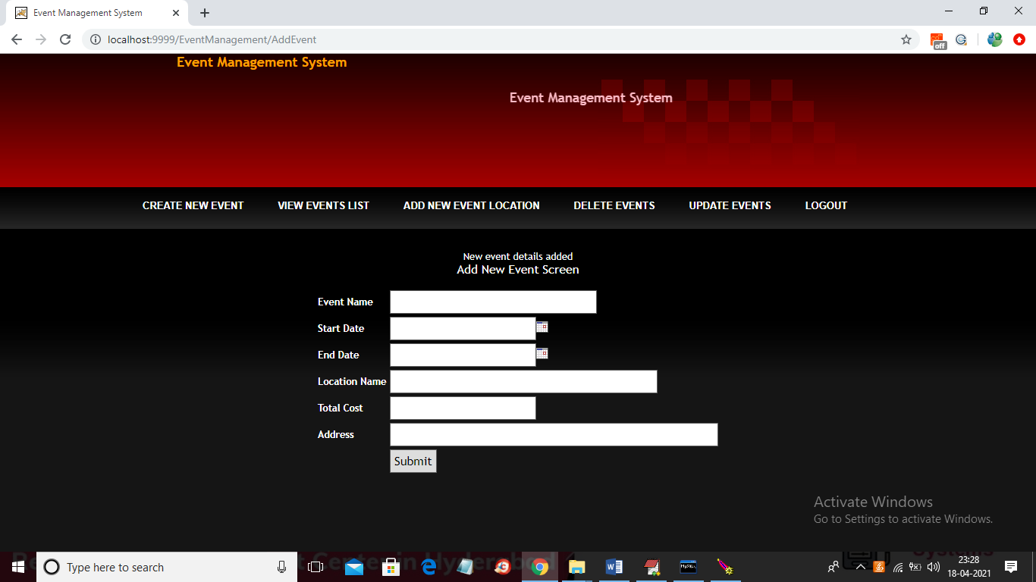

In above screen event details added and now click on ‘View events List” to view all event list

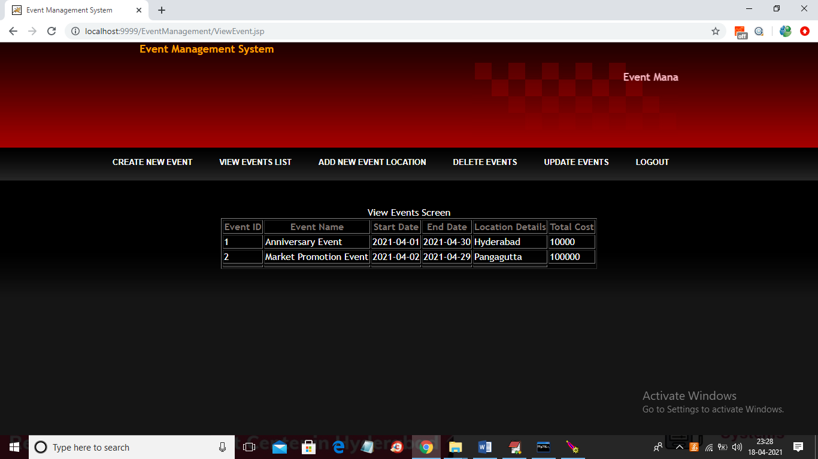

In above screen we can see all event list and now click on ‘Add New Event Location’ link to add location for events

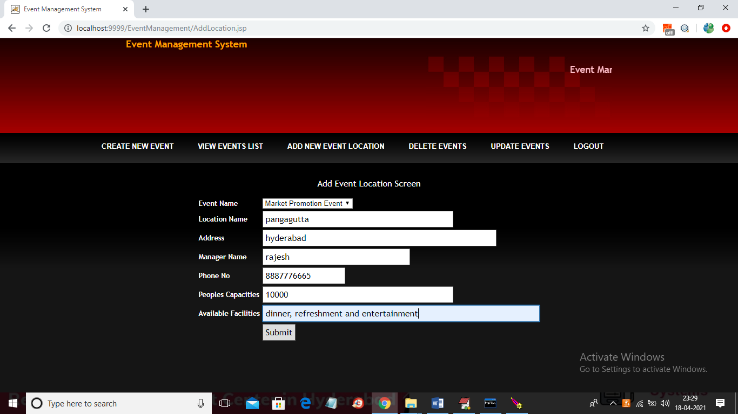

In above screen adding location details by selecting event and then click on submit button to add location for selected event.

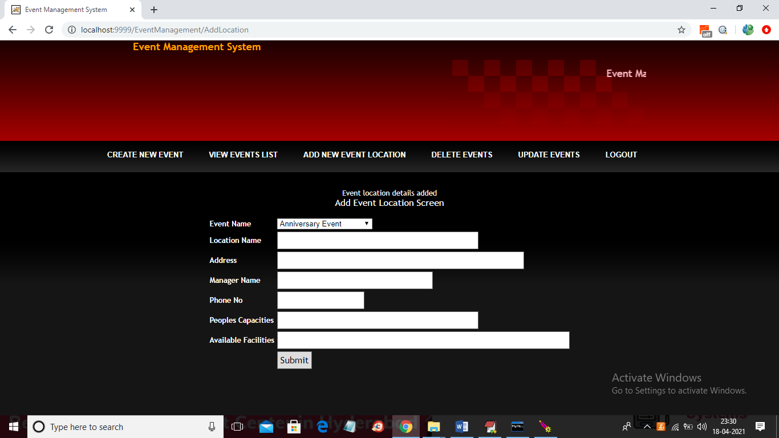

In above screen event location details added and now click on ‘Delete Events’ link to delete events

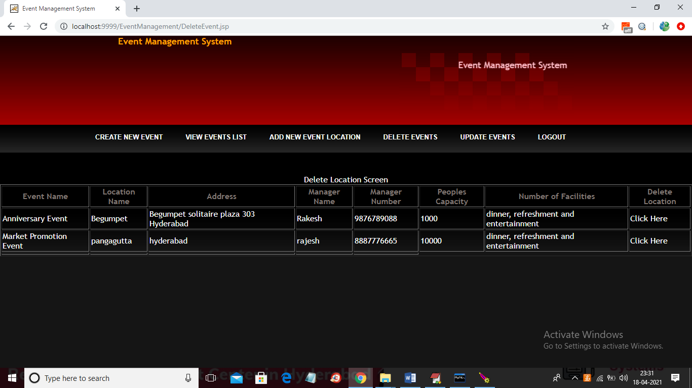

In above screen user can click on ‘Click Here’ option to delete event details and now click on ‘Update events’ link to get below screen

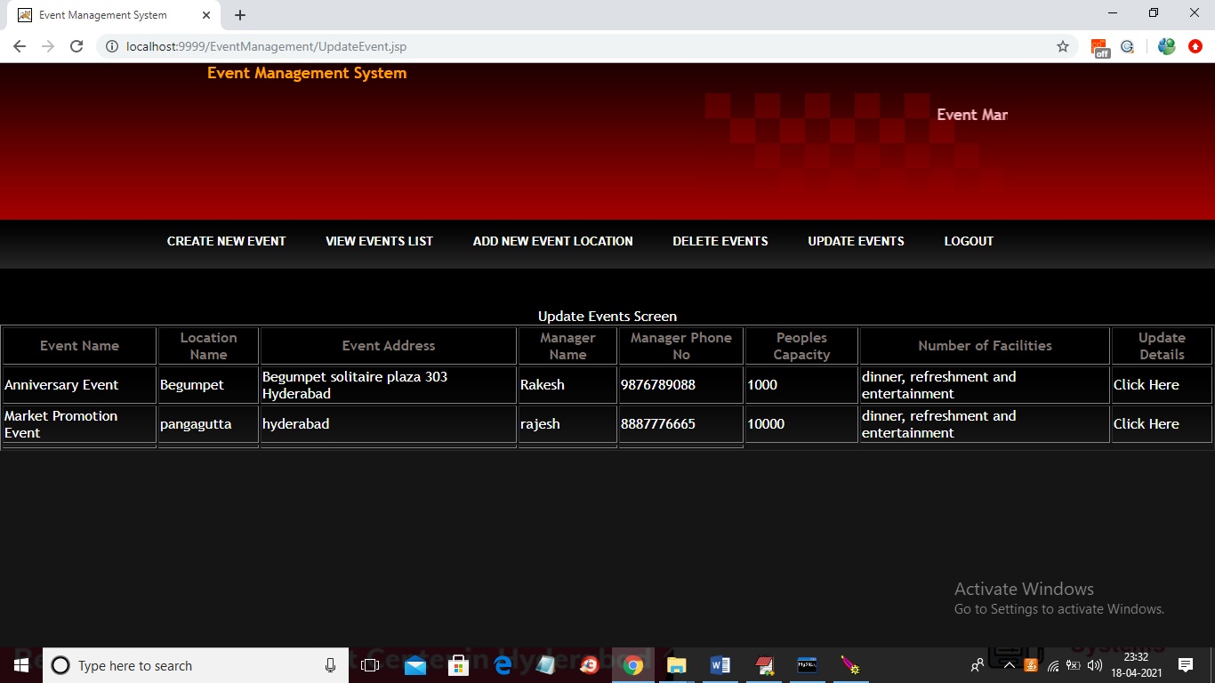

In above screen click on ‘Click Here’ link to update any record and to get below screen

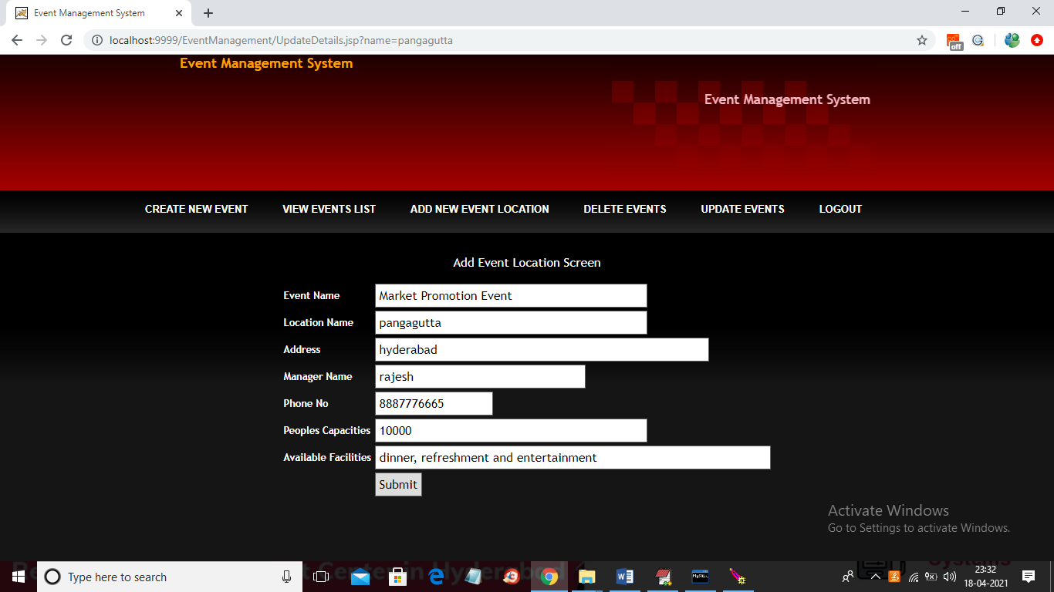

In above screen update any details and press on submit button to update details

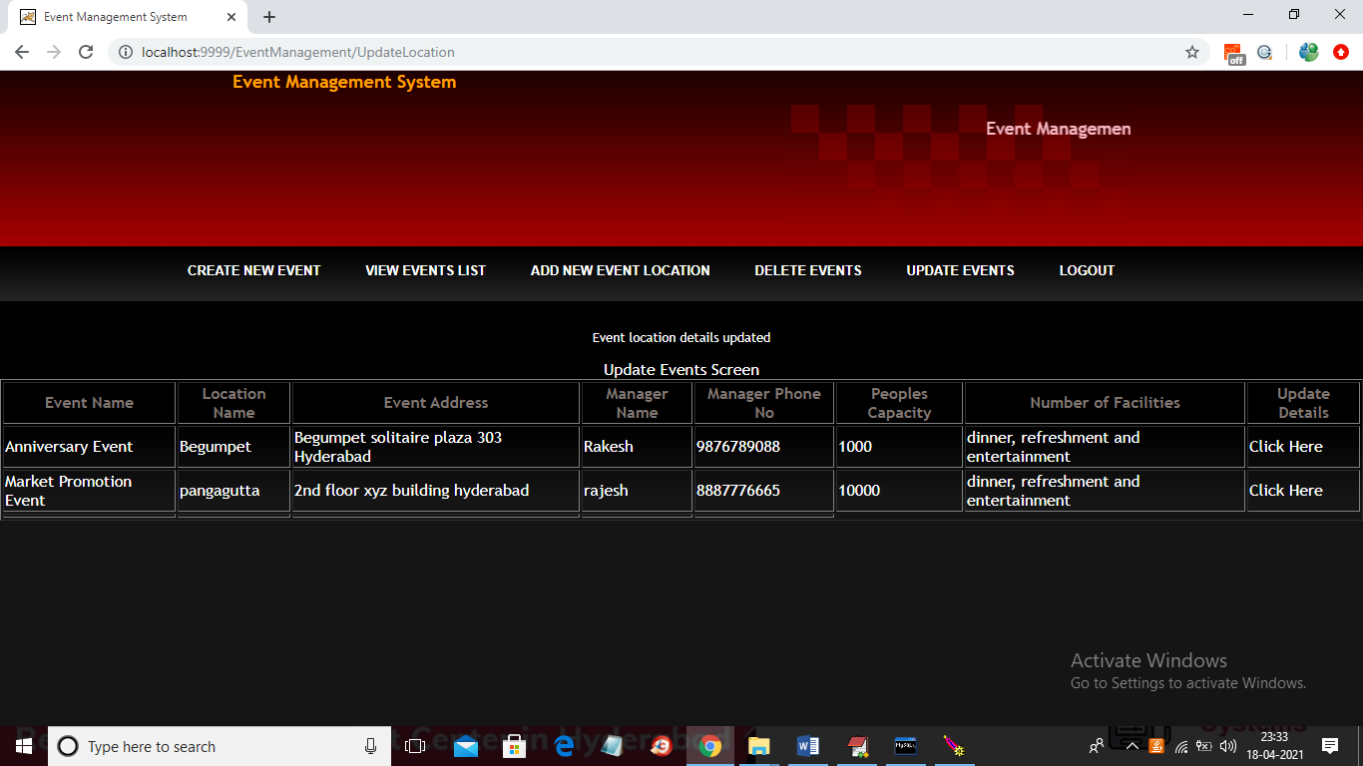

In above screen address is updated and now logout to get below screen

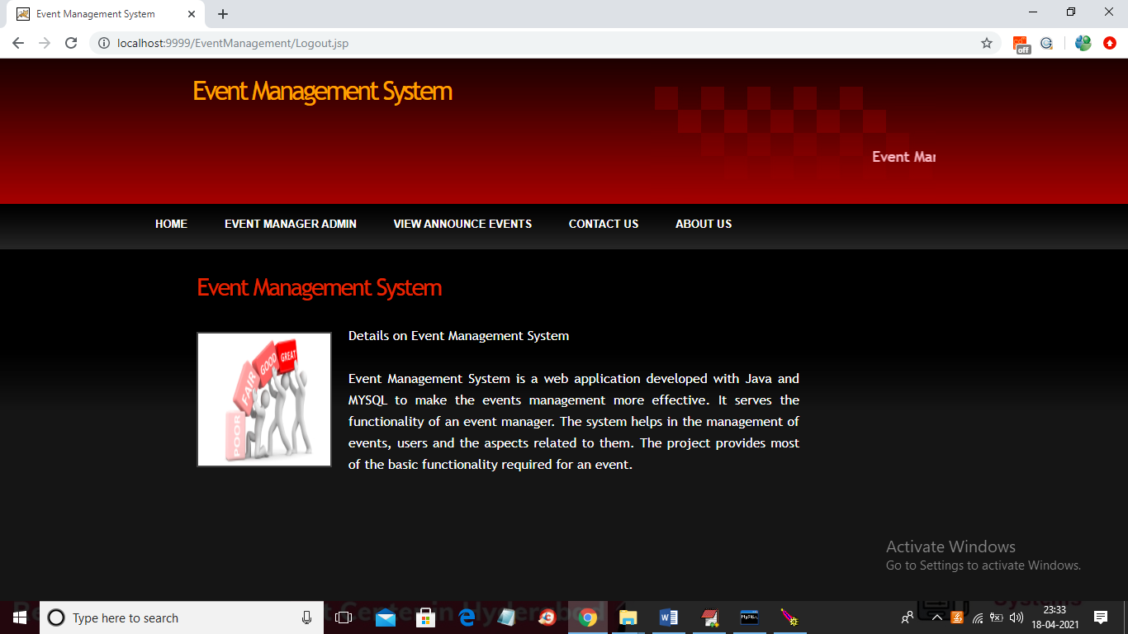

In above screen click on ‘View Announce events’ link to get below details which can access by any normal user

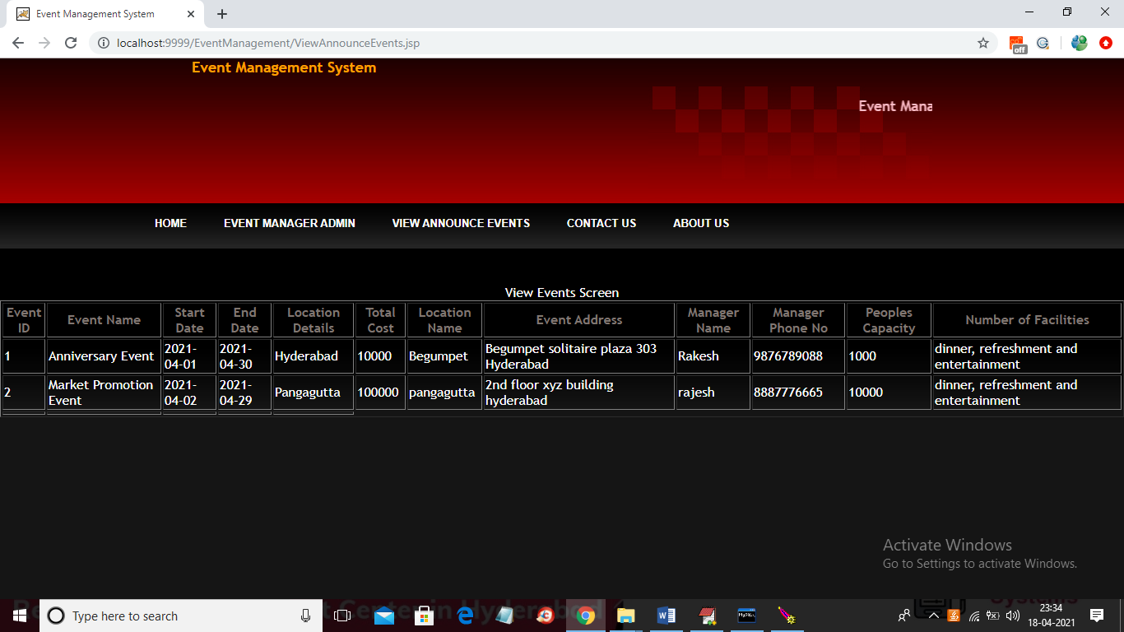

In above event announcement screen user can view event and location details